**Planning Proposal to permit additional industrial uses, including rural industries, at identified key sites**

**New England Highway, Muswellbrook (PP-2024-732)**

|  |  |  |
| --- | --- | --- |
| **Local Government Area:** | | Muswellbrook Shire Council (MSC) |
| **Name of Draft LEP:** | | Muswellbrook Local Environment Plan 2009 (PP-2024- 732) Amendment No. 22 |
| **Subject Land:** | | Site 1 - Part Lot 2 DP1095515.  Site 2 - Part Lot 2 DP1095515.  Site 3 - Part Lot 601 DP1019325, part Lot 34 DP 752486 and part Lot 145 DP 752486. |
| **Land Owner:** | | AGL Macquarie P/L |
| **Applicant:** | | AGL Macquarie P/L |
| **Folder Number:** | | PP-2024-25 |
| **Date:** | | 28/05/2025 |
| **Authors:** | | Sharon Pope, Muswellbrook Shire Council  Trent Wink, Department of Planning, Housing and Infrastructure Luke Fanayan, Department of Planning, Housing and Infrastructure |
| **Tables:** | Table No. | Details |
|  | 1 | Summary of amendments to MLEP 2009 |
|  | 2 | Change in Key Site Area |
|  | 3 | Assessment of Hunter Regional Plan 2041 |
|  | 4 | Assessment of Muswellbrook Local Strategic Planning Statement 2020 - 2040 |
|  | 5 | Assessment of Muswellbrook Community Strategic Plan 2022-32 |
|  | 6 | Assessment of State Environmental Planning Policies |
|  | 7 | Assessment of Section 9.1 Directions |
|  | 8 | Assessment of other Environmental Effects |
|  | 9 | Agency Consultation |
| **Maps:** | No. |  |
|  | 1 | Locality |
|  | 2 | Aerial |
|  | 3 | Site Identification |
|  | 4 | Bushfire |
|  | 5 | 1. Zoning map 2. Key Sites map |
|  |  |  |

|  |  |  |
| --- | --- | --- |
| **Attachments:** | No. | Details |
|  | 1 | Evaluation criteria for the delegation of plan making functions. |
|  | 2 | Bushfire Risk Management Plan |
|  | 3 | Aboriginal Heritage information Management System (AHIMS) records |
|  | 4 | Traffic Impact Assessment |
|  | 5 | 1. Gateway determination dated 13 June 2024 2. Gateway Alteration dated 28 Nov 2024 |
|  | 6 | Preliminary Site Investigation |

**Part 1 – OBJECTIVES OR INTENDED OUTCOMES**

The intent of the planning proposal (PP) is to amend *Muswellbrook Local Environmental Plan 2009* (MLEP 2009). The amendment will make industrial uses, including rural industries, permissible with consent on three (3) key sites. The three (3) sites have a combined area totalling 105.24 hectares.

The current zoning of SP2 Infrastructure zone only permits a limited range of uses. The amendment will facilitate the ongoing transition of existing Power Station Sites to permit a broader range of employment generating activities. A development control plan will need to be prepared before any development consent is granted on the subject land. It will address key issues, site characteristics and manage the delivery and sequencing of essential infrastructure. Land uses being envisaged include solar panel manufacturing, solar panel refurbishment and recycling, green steel production and agricultural industries.

This PP also aims to permit ancillary infrastructure in the SP2 zone not already covered and made permissible under *State Environmental Planning Policy (Transport & Infrastructure) 2021*.

**Part 2 – EXPLANATION OF PROVISIONS**

The intended outcomes will be achieved by amending the MLEP 2009 as follows: -

|  |  |
| --- | --- |
| **Amendment Applies to** | **Explanation of provision** |
| Amend the SP2 Infrastructure land use table | To include “Environmental Protection Works” as a use permitted without consent; To include “Roads” and “Water Storage Facilities” as uses permitted with consent.  * “Sewage reticulation”, “Sewage treatment plants” and “Water supply systems” (except for the sub term of water storage facility) are not proposed to be added to the SP2 zone table because these uses are already permitted with consent under the *SEPP (Transport & Infrastructure) 2021*. |
| Key Sites Maps – Sheet KYS_009 | To create a new map sheet identifying the 3 sites. |
| Part 7 Additional Local Provisions | To include a new local clause to permit “Industry” and “Rural Industry” land uses. The local clause requires the preparation of a development control plan before any development consent is granted to development on the subject land. The proposed Additional Local Provision is outlined below. |

**Table 1 – Summary of MLEP 2009 Amendments**

Proposed drafting of local clause under Part 7 – Additional Local Provisions:

*“7.11 Development on land associated with part Lot 601 DP1019325, part Lot 2 DP1095515, part Lot 34 DP 752486 and part Lot 145 DP 752486.*

*(1) The objectives of this clause are as follows:*

*(a) to facilitate the ongoing transition of existing Power Station Sites from coal fired power station operations to a broader range of employment generating activities; and*

*(b) to facilitate development that is compatible with or related to the special characteristics of the site and recognises the site constraints and the available infrastructure.*

*(2) This clause applies to land identified as part Lot 601 DP1019325, part Lot 2 DP1095515, part Lot 34 DP 752486 and part Lot 145 DP 752486 on the Key Sites Map.*

*(3) Despite clause 2.3, development consent may be granted to development for the purpose of:*

*Industry; Rural industry*

*(4) Development consent must not be granted to development on land to which this clause applies unless the consent authority is satisfied that:*

*a) there are no significant land use conflicts between the proposed development and the land uses conducted on the adjoining parts of the site; and*

*b) The uses are compatible with or otherwise relate to the special characteristics of the site.*

*(5) Development consent must not be granted for development on land to which this clause applies unless a development control plan that provides for the matters specified in subclause (6) has been prepared for the land.*

*(6)* *The development control plan must provide for the following—*

*(a) a staging plan for the timely and efficient provision of necessary infrastructure,*

*(b) an overall transport movement hierarchy showing the major circulation routes and connections to achieve a safe movement system for private vehicles, public transport, pedestrians and cyclists,*

*(c) an overall landscaping and vegetation management strategy for the protection and enhancement of riparian areas and remnant vegetation, including visually prominent locations, and detailed landscaping requirements to manage views of the sites both from the public and private domain,*

*(d) the location of flora, fauna and vegetation corridors,*

*(e) stormwater and water quality management controls,*

*(f) amelioration of natural and environmental hazards, including bushfire, flooding and site contamination and, in relation to natural hazards, the safe occupation of, and the evacuation from, any land so affected,*

*(g) detailed urban design controls for significant development sites*

*(7) Subclause (5) does not apply to development for any of the following purposes—*

*(a) a subdivision for the purpose of a realignment of boundaries that does not create additional lots,*

*(b) a subdivision of land if any of the lots proposed to be created is to be reserved or dedicated for public open space, public roads or any other public or environment protection purpose,*

*(c) development on land that is of a minor nature only, if the consent authority is of the opinion that the carrying out of the development would be consistent with the objectives of the zone in which the land is situated.*

The development assessment process will determine the suitability of the proposed development and take into consideration the special characteristics, site constraints and infrastructure requirements.

All other planning controls applying to the site will remain unchanged.

* 1. ***Post-Exhibition Amendments by Council***

It was decided upon approving the final mapping data to adjust the spatial location of the key sites identified in this planning proposal. As a result, minor boundary refinements have been made to the three key sites. These changes aim to:

* Better reflect the physical characteristics of each site, including the avoidance of existing tree stands.
* Provide appropriate separation from bushland and riparian areas.
* Align boundaries with the configuration of existing access roads and car parking areas on adjacent land.

These amendments do not alter the intent, objectives, or zoning outcomes of the planning proposal. Rather, they support a more efficient and responsive land use outcome that better fits the local site context. The changes in key site area range from 1.00% to 7.8%. This scale of change is consistent with what is commonly recognised as a minor boundary amendment in the context of local environmental planning provisions and practice. They do not introduce any additional development capacity beyond what was envisaged in the original planning proposal and do not materially affect the strategic intent, zone objectives, or environmental considerations. Updated mapping reflecting these changes is provided in Part 4 – Mapping.

The changes in area are summarised in the table below:

|  |  |  |  |
| --- | --- | --- | --- |
| **Key Site** | **Original (ha)** | **New (ha)** | **% Change** |
| Key Site 1 | 10.5358 | 11.1890 | 6.20% |
| Key Site 2 | 9.7117 | 10.4644 | 7.77% |
| Key Site 3 | 84.9868 | 85.8364 | 1.00% |

**Table 2 – Change in Key Site Area**

**Part 3 – JUSTIFICATION**

**Section A – Need for the Planning Proposal**

* 1. ***Is the planning proposal a result of any strategic study or report?***

The planning proposal is not the result of a strategic study or report. The PP gives effect to Planning Priorities 1-3 in the Muswellbrook Local Strategic Planning Statement dated October 2020 (LSPS). It also aligns with the Hunter Regional Plan 2041, which identifies Liddell & Bayswater as a regionally significant growth area because of its employment generating potential. This is discussed in more detail in Section B, below.

The AGL landholdings, located in Muswellbrook Local Government Area, are primarily zoned SP2 Infrastructure under MLEP 2009. It comprises a coal fired power station, a former coal fired power station that is scheduled for demolition, and ancillary infrastructure, such as ash dams, coal stockpile areas, coal conveyancing equipment, electricity switching yards, and electricity transmission lines.

The former Liddell Power Station (Liddell PS) was initially constructed by the NSW Government owned State Electricity Commission. It operated from the early 1970s until its closure in April 2023. AGL has decommissioned the building which has involved isolating hazards, decontaminating the plant and ensuring it is safe and ready for demolition. When the State Significant Development is approved, demolition can commence. On completion of the demolition works, the Liddell PS site will be rehabilitated in line with regulatory requirements.

Bayswater Power Station (Bayswater PS) was also constructed by the State Electricity Commission and has been operating since 1985, along with the Hunter Valley Gas Turbines and a range of infrastructure to support water supply, water management, coal ash management, coal supply, power supply and control systems. Bayswater PS is scheduled to cease generating electricity between 2030 and 2035.

The landholdings provide an opportunity to attract employment generating development to create jobs for the skilled workforce impacted by the energy transition and the future closure of Bayswater PS and local mines.

* 1. ***Is the planning proposal the best means of achieving the objectives or intended outcomes, or is there a better way?***

Yes. The proposed local clause will permit a broader range of permissible land uses for three (3) identified sites within the much larger AGL landholdings. Another project is underway to master plan the larger holding (across two Council areas) but this will take time and some new uses need to be established on the site before closure of the Bayswater PS.

All future land uses will require the lodgement of a development application, assessed under the EP&A Act and development consent being granted. This is considered consistent with the underlying objective to facilitate employment generating activities which support the renewable energy transition, while the Bayswater PS is still operating. The development assessment process will take into consideration the special characteristics, site constraints and infrastructure requirements.

Other options considered and not pursued include:

* **Amending Schedule 1, Additional Permitted Uses** to permit the uses identified above. This option is not the preferred option because it does not include objectives that make clear that the intent of the additional permissible uses is to support the renewable energy transition. This option does not provide detailed development control to support the identified land uses and the future development of the land.
* **Amend the SP2 Infrastructure Zone Table to permit Industries with consent**. This option would apply to all land zoned SP2 Infrastructure under MLEP 2009 and has the potential to allow for inappropriate land uses to occur on other sites within the Muswellbrook Local Government Area (LGA). This option also does not provide detailed development control to support the identified land uses and the future development of the land. It is not preferred for these reasons.
* **Split SP2 Infrastructure/SP4 Enterprise zone and mapping the site as an Urban Release Area under Part 6 of the LEP to require a Development Control Plan**. This option was suggested by DPHI but is not preferred for this planning proposal as MLEP 2009 does not currently contain a SP4 Enterprise zone, so it would be inconsistent with Ministerial Direction 1.4, given it would seek to rezone the site to a zone not already in the LEP, and Direction 7.1 given there is not currently a strategy approved by the Planning Secretary to create an employment zone on this site.

Council is intending to seek to use the SP4 zone for several “transition” sites across the Shire, predominantly open cut coal mine sites that are expected to cease operation in the short term. The full range of uses that may be permitted in the SP4 zone is not settled, but would likely include office and light industrial uses, limited residential accommodation, childcare, education establishments, intensive agriculture, local shops and so on, which would be inconsistent with the primary use of the Bayswater Power Station site for electricity generation until closure.

In summary, the proposal is the best means of achieving the objectives and intended outcomes as it provides an opportunity to permit desirable land uses consistent with the underlying objective to facilitate employment generating activities which support the renewable energy transition.

**Section B – Relationship to Strategic Planning Framework**

* 1. ***Is the planning proposal consistent with the objectives and actions of the applicable regional or sub-regional strategy (including the Sydney Metropolitan Strategy and exhibited draft strategies)?***

Hunter Regional Plan 2041 (HRP)

The PP is consistent with the HRP strategic directions. It implements the objectives to diversify the Hunter’s mining, energy and industrial capacity and to plan for other employment generating opportunities and activities in the Liddell and Bayswater power stations.

The Liddell and Bayswater power station site is recognised as a regional significant growth area. The HRP requires place strategy planning be undertaken to investigate employment and environmental outcomes, whilst considering infrastructure capabilities, including water supply. However, the Department recently advised that the Hunter and Central Coast Place Delivery Program, currently implemented through the UDPs, has been reviewed. The place strategy requirement to accompany future planning proposals has been removed and Council should proceed with its local planning pathway with planning proposals informed by proponent prepared site-specific investigations.

To inform future employment and environmental outcomes, Council will continue to work with AGL to develop a master plan to identify how the land should be developed and constraints managed. An infrastructure strategy and delivery plan is also required in conjunction with the master plan, to determine capacity and infrastructure gaps.

An assessment of the HRP key strategies is outlined below:

| **Hunter Regional Plan 2041** |
| --- |
|  |

|  |  |  |  |
| --- | --- | --- | --- |
| ***Objective*** | ***Performance Outcome*** | ***Strategy*** | ***Alignment*** |
| OBJECTIVE 1:  Diversify the Hunter’s  mining, energy and industrial capacity | Any planning proposal or  local strategic planning  statement that does not  comply with a strategy in  this objective must  demonstrate how the  following performance  outcomes will still be  achieved:  1. Power stations and  coal mines facilitate  diverse job  opportunities on their  land either during  operation or following  closure, with land uses  responsive to the  characteristics of the  locality.  2. Employment lands  provide a variety of  employment uses and  diversify the  employment base.  3. Employment lands  close to inter-regional  links support freight,  logistics and industries  which benefit from  connections to interregional  or global  markets.  4. Employment lands  close to renewable  energy zones support  manufacturing related  to renewables and  energy intensive  industries and  clustering of business  which supports those  activities.  5. Circular economy  industries and facilities  are in appropriate sites.  6. New employment lands  are serviced, manage  biodiversity impacts  and are situated to  avoid land use conflict.  7. Employment lands are  retained and  safeguarded by limiting  the encroachment of  sensitive land uses. | Strategy 1.1  Planning proposals for mine or power station sites identified as regionally significant growth areas  will be supported by a place  strategy which demonstrates how the proposal will:  – maximise employment  generation or will attract  visitors to the region.  – make use of voids and/or site infrastructure such as rail loops, hard stand areas,  power, water and road access.  – support the growth of  adjoining industrial areas or  settlement areas.  – enhance corridors within the landscape such as biodiversity corridors or disused infrastructure corridors.  – complement areas with  special amenity value such as critical industry clusters, open space, villages and residential areas.  – have considered the existing and likely future uses of adjoining land and avoid land use conflict.  – align with any specific  guidance in the district  planning priorities section of  this plan.  Strategy 1.2  Following completion of the  Hunter– Central Coast REZ, local strategic planning should consider:  – opportunities to leverage new employment in related  manufacturing and energy  intensive industries that  benefit from proximity to the  energy infrastructure within  the renewable energy zone.  – the proximity of sensitive land uses to ensure sensitive land uses do not encroach on activities within the REZ.  Strategy 1.3  Local strategic planning should consider:  – how existing employment land areas, including those that provide urban services, will be retained unless opportunities for urban renewal arise through the relocation of industry.  – if there is sufficient supply of vacant, serviced employment land providing capacity for a range of different sized employment enterprises the employment land needs for the local government area and  identify flexible planning and  development control  frameworks to support their  growth.  – opportunities to facilitate  growth in logistics, circular  economy, new economic  enterprises and industries and their supply chains.  – the suitability of transport  interchanges and bypasses for employment lands in  consultation with Transport for NSW.  – lands around the interchanges of the M1 Pacific Motorway and Pacific Highway should be used for employment activities that benefit from easy access  to key markets such as  manufacturing, logistics and  warehousing.  – the proximity of sensitive land uses and ensure they do not encroach upon these areas.  Strategy 1.4  Planning proposals for new  employment lands will  demonstrate they:  – are located in areas which will not result in land use conflict.  – can be adequately serviced and any biodiversity impacts are manageable.  – respond to the employment land needs identified for that local government area. | The Liddell and Bayswater Regionally Significant Growth  Area map (Figure 24) identifies the site as a future “Integrated Industrial energy hub”.  Council has been advised to proceed with preparing planning proposals informed by proponent prepared site-specific investigations to determine employment and environmental outcomes.  The proposed local clause will permit a broader range of permissible land uses for three identified sites within the much larger AGL landholdings. Future development will be required to be consistent with the objective of the local clause to facilitate employment generating activities which support the renewable energy transition and minimise social and economic impacts.  Employment opportunities in manufacturing, waste, freight and other industries should assist in providing jobs for the existing skilled workforce impacted by the energy transition and the future closure of Bayswater PS and local mines.  It will also provide opportunities for circular economy industrial uses to reuse ash and other products during manufacturing processes by enabling  co-location on the Bayswater site.  The site offers both rail and highway access, water and infrastructure assets. |

**Table 3 Assessment of Hunter Regional Plan 2041**

* 1. ***Is the planning proposal consistent with a council’s local strategy or other local strategic plan?***

The PP gives effect to Planning Priorities 1-3 in the Muswellbrook LSPS as outlined in the Table 3 and implements the economic diversity goal of Muswellbrook Strategic Plan 2022-32 outlined in Table 4 below:

| **Muswellbrook Shire Local Strategic Planning Statement 2020-2040** |
| --- |
|  |

|  |  |  |
| --- | --- | --- |
| **Priority** | **Detail** | **Consistency** |
| Planning Priority 1:  Our Shire embraces technology and innovation. | Council supports leading edge businesses growing and consolidating in Muswellbrook Shire as a mechanism toward supporting the Shire’s transition to broader employment diversification. | The proposal will enable the lodgement of DAs for industrial land uses on the site, assisting with employment diversification opportunities. It will also provide opportunities for industrial uses to beneficially reuse ash and other  by-products on the Bayswater site. |
| Planning Priority 2:  We plan for the transition of mine and power station sites before their closure. | Mines and power stations occupy large tracts of land with infrastructure and topography that would be suitable for alternative uses over time, to replace employment opportunities that may not exist in the future. | The site is suitable for various industrial land uses that will provide employment opportunities in the LGA. |
| Planning Priority 3:  The mineral resource and power generation industry is productive, accountable and considerate of surrounding land uses | Coal mining, river sand extraction and quarrying for hard rock and shale are major components of  the economy of the Shire. The two coal fired power stations are expected to close long-term, but new power generating activities, such as wind, solar, pumped hydro and biofuels are expected to be commissioned.  Groups from the mining, quarrying and agricultural and visitor economy sectors have expressed a desire for certainty on the location of these different activities, enabling more confidence in investment decisions. Many of these activities are classed as State Significant Development (SSD) but Council  has a strong role in advocating for appropriate land use planning decisions by the State Agencies. | As above.  DA’s will be assessed on their merits in accordance with the requirements of the EP&A Act. |

**Table 4 Assessment of Muswellbrook LSPS 2020-2040**

| **Muswellbrook Shire Council Community Strategic Plan 2022-2032** |
| --- |
|  |

|  |  |
| --- | --- |
| **Goal** | **Consistency** |
| Economic prosperity. Strategy 1.2 of this goal is to:  *“Diversify the economy, facilitate the development of*  *intensive agriculture, innovative manufacturing, health services and other growth industries”.* | This proposal seeks to make industrial land uses permissible with consent on the site. It will also provide opportunities for innovative industrial manufacturing uses which beneficially reuse ash and other generation by-products during manufacturing processes by enabling co-location on the Bayswater site. |

**Table 5 Assessment of Muswellbrook Community Strategic Plan 2022-32**

***4.3 Is the Planning Proposal consistent with any other applicable State and regional studies or strategies?***

The proposal is consistent with the following State Plans and Strategies:

– NSW State Plan 2021

– NSW State Infrastructure Strategy 2022-2042

– Future Transport Strategy

– A 20 Year Economic Vision for Regional NSW

***4.4 Is the planning proposal consistent with applicable State Environmental Planning Policies?***

The PP is consistent with applicable State Environmental Planning Policies as outlined below:

| **Assessment of the Planning Proposal against relevant SEPPs** |
| --- |

|  |  |  |  |
| --- | --- | --- | --- |
| **SEPPs** | **Applicable** | **Consistent** | **Comment** |
| (Biodiversity and Conservation) 2021 | No | NA | The proposal itself does not propose to clear vegetation or affect land subject to potential koala habitats, foreshore or waterways, water catchments, or  strategic conservation areas.  Any future development applications will be assessed in accordance with the requirements of this SEPP. |
| (Exempt and complying Development Codes) 2008 | No | NA | The proposal does not propose any building works or changes to this policy. |
| (Housing) 2021 | No | NA | The proposal does not propose building works or changes to this policy, and no residential uses are proposed to become permissible as part of this proposal. |
| (Industry and Employment)  2021 | No | NA | The proposal does not propose any changes to the planning controls for advertising and signage. The land is not located in the Western Sydney employment area. |
| No 65 – Design Quality of  Residential Apartment Development | No | NA | The proposal does not propose building works or changes to this policy, and no residential uses are proposed to become permissible as part of this proposal. |
| (Planning Systems) 2021 | Yes | Yes | The proposal does not affect the assessment of any future proposed State significant development, State significant infrastructure, Regionally significant development or land subject to a development Delivery Plan. The land is not owned by an Aboriginal Land Council. |
| (Primary Production) 2021 | No | NA | Land subject to the proposal is not primary production or rural development, located on state significant agricultural land, a farm dam and other small-scale and low risk artificial waterbody, a livestock industry,  sustainable aquaculture or within the Central Coast plateau area |
| (Resilience and Hazards)  2021 | Yes | Yes | The site is not located in the coastal zone. If a DA for a hazardous or offensive development is lodged it will be  assessed on its merits.  The site is not listed on the significantly contaminated land register and is currently used for power station related purposes, being a form of industrial development, and regulated under an environmental protection licence issued by the NSW EPA.  The Preliminary Site Investigation (PSI) prepared by GHD and dated 29 November 2024 concludes that the overall likelihood for significant chemical contamination to be present within Sites 1, 2 and 3 is considered to be moderate based on the current use and past activities and the surrounding areas. It notes that the planning proposal does not propose to change the use of the land from a contamination perspective in that the sites are currently used for power station related purposes, being a type commercial/industrial use and it is expected that each site can be made suitable for the proposed land uses.  The assessment of future development applications under the *Environmental Planning and Assessment Act 1979* will include consideration of *State Environmental Planning Policy (Resilience and Hazards) 2021* and be accompanied by a Detailed Site Investigation Report to confirm the status of contamination and any remediation works required.  Required remediation works can be regulated and validated via development consent conditions to ensure that the suitability of the site for the proposed industrial development. |
| (Resources and Energy) 2021 | No | NA | The proposal is compatible with the surrounding separately approved mining operations which adjoin the Site and does not propose any changes to the controls contained in this SEPP. MSC recently approved a boundary realignment (DA 2023-130) to allow the transfer of land already approved for mining to Maxwell Ventures. This further protects and recognises its approved use. Consultation will be undertaken with NSW Mining, Exploration and Geosciences as required by the Gateway determination. |
| (Sustainable Buildings) 2022 | No | NA | The proposal does not propose building works or changes to this policy, and the site is not on land zoned for residential purposes. |
| (Transport and Infrastructure) 2021 | Yes | Yes | The proposal does not propose building works or changes to this policy. Future developments made permissible by this planning proposal may require referral to TFNSW depending on the type of development and traffic generation. |

**Table 6 Assessment of State Environmental Planning Policies**

* 1. ***Is the planning proposal consistent with applicable Ministerial Directions?***

An assessment of the PP and its consistency against the applicable Ministerial Directions is provided below:

| **Compliance with Section 9.1 Directions** |
| --- |

|  |  |  |
| --- | --- | --- |
| 1.1 Implementation of Regional Plans | Consistent | The proposal is consistent with the objectives and actions of the Hunter Regional Plan 2041 |
| 1.2 Development of Aboriginal Land Council land | NA |  |
| 1.3 Approval and Referral Requirements | Consistent | The proposal does not include any provisions that require additional concurrence, consultation, or referral of development applications to a Minister or  public authority and does not identify development as designated development. |
| 1.4 Site Specific Provisions | Consistent | The proposal will amend the LEP to make ‘industry’ ‘Rural Industry’ and additional infrastructure related land uses permissible with consent. The Proposal does not require rezoning to a land use that is not in the LEP.  The proposal does not seek to include any new land uses that are not already defined in the LEP. |
| 1.4A Exclusion of Development Standards from Variation | NA |  |
| 3.1 Conservation Zones | NA | The site does not contain environmentally sensitive areas, land within a conservation zone or identified  for environment conservation or protection purposes. |
| 3.2 Heritage Conservation | Consistent | The proposal does not affect existing heritage provisions in the LEP. |
| 4.1 Flooding | NA | There is no flood study available for this site. The site does not adjoin a river, and Lake Liddell is a constructed water body that is kept full by water discharged from Bayswater PS. The Site is not considered to constitute Flood Prone Land.  The Gateway determination (covering letter dated 13/6/24) approved any potential inconsistency with this Direction on the basis that the land is not considered flood prone and this issue will be further considered at the DA stage. |
| 4.3 Planning for Bushfire Protection | Inconsistent | The planning proposal has a minor inconsistency with the Minister’s Direction 4.3 Planning for Bushfire Protection because it doesn’t introduce asset protection zones and other specific bushfire requirements.  The site is mapped as Bushfire Prone Land - Vegetation Category 3. Bushland on the site is fragmented. Grassland is the predominant vegetation type.  Future land uses will be subject to different risk profiles and accordingly APZ and BAL requirements. The existing road network is considered to have sufficient capacity, ingress and egress to accommodate evacuation, and emergency services vehicles. Key access routes would remain unchanged from those approved under previous consents/Bushfire Management Plan. Stored water is available at the site, primarily in storage dams.  The NSW Rural Fire Service (NSW RFS) was consulted as required by the Gateway determination. NSW RFS advises that future developments will need to comply with Planning for Bushfire Protection guidelines.  The Secretary approved the minor inconsistency with this Direction on 14 February 2025 on the basis that the NSW Rural Fire Service raised no objection. |
| 4.4 Remediation of Contaminated Land | Consistent | The site is not listed on the significantly contaminated land register but is currently used for  power station related purposes, being a form of industrial development, and regulated under environmental protection licences issued by the NSW EPA. The EPLs may need to be varied depending on the future development outcomes.  The Preliminary Site Investigation (PSI) prepared by GHD and dated 29 November 2024 confirms that several contamination investigations have been completed, however these investigations did not focus on Sites 1 to 3 as they are outside the main operational area. While some investigation of Sites 1 to 3 was undertaken as part of these studies, the PSI identified that these investigations were not comprehensive. The EPA understands the PSI has indicated that the land can be made suitable for the proposed uses, on the recommendation that further investigation is required to assess the nature and extent of contamination across the three sites.  The EPA recommends that the Planning Authority should seek to put in place mechanisms, through an Environmental Planning Instrument (LEP or DCP), that ensure, in the event the proposal is approved, the additional contamination investigations outlined in the “Conclusions and Recommendations” section of the PSI are carried out prior to any development taking place to those areas of the site where additional investigations are recommended. Council is satisfied that future remediation works will be undertaken as part of the development consent and prior to the issue of any Construction Certificate. A LEP or DCP requirement is not considered warranted in this instance.  In conclusion, Council is satisfied that the land is suitable in its contaminated state (or will be suitable, after remediation) for the proposed permitted industrial land uses before the planning proposal is finalised. |
| 4.5 Acid Sulfate Soils | NA |  |
| 4.6 Mine Subsidence and Unstable Land | NA | A small portion of land adjacent to the southern eastern end of Lake Liddell owned by AGL is located within a Mine Subsidence District but does not apply to the identified sites. |
| 5.1 Integrating Land Use and Transport | Consistent | The Direction does not strictly apply to this PP. It aims to broaden the permissible industrial uses on land zoned SP2 Infrastructure to facilitate employment generating activities which support the renewable energy transition.  The PP is considered consistent with the underlying principles of Improving Transport Choice – Guidelines for planning and development (DUAP 2001), and The Right Place for Business and Services – Planning Policy (DUAP 2001) by creating employment opportunities on a site, suitability located on the outskirts of Muswellbrook, with direct access to the New England Highway. It should positive contribute to employment opportunities for the skilled workforce impacted by the closure of the power stations and local mining operations. |
| 8.1 Mining, Petroleum Production and Extractive Industries | Consistency | This direction applies to planning proposals that could have the effect of restricting the potential development of resources of coal, other minerals, petroleum or extractive materials which are of State or regional significance by permitting a land use that is likely to be incompatible with such development.  The proposal could hypothetically restrict the future mining of coal resources on the site. However, it should be noted that the site already contains significant infrastructure which restricts/limit mining opportunities if made permissible. The PP doesn’t propose to change the mining prohibition.  NSW Resources was consulted as required by the Gateway determination and this Direction. NSW Resources advises that it raises no resource sterilisation issues with this planning proposal proceeding.  The Department agrees that the planning proposal has now demonstrated that it is consistent with section 9.1 Direction 8.1 Mining, Petroleum Production and Extractive Industries. |

**Table 7 Assessment of Section 9.1 Directions**

**Section C – Environmental, Social and Economic Impact**

***5.1 Is there any likelihood that critical habitat or threatened species, populations or ecological communities, or their habitats, will be adversely affected as a result of the proposal?***

The identified sites are located within highly disturbed landscape areas and do not contain any large expanses of intact native vegetation. The land has low ecological value.

No areas of the site have been declared as an area of outstanding biodiversity value in accordance with section 3.1 of the *Biodiversity Conservation Act 2016* (the ‘BC Act’) would be affected.

***5.2 Are there any other likely environmental effects as a result of the planning proposal and how are they proposed to be managed***

An assessment of other environmental effects and how it will be managed is provided below.

|  |  |
| --- | --- |
| **Environmental Impact** | **Comment** |
| Bush Fire | Sites 1 and 2 are currently managed as active operational areas of the BPS and are regulated by the specific Hazard Management Plans contained in Attachment 2. Site 3 is part of the now decommissioned Liddell PS and contains limited vegetation and is mapped as Vegetation Category 3. Vegetation on this site is controlled by slashing/weed spraying. Ten-metre-wide fire breaks along the inside highway boundary fence.  The Bushfire Risk Management Plan is provided in **Attachment 2**. Consultation will be undertaken with NSW Rural Fire Service (RFS) as required by the Gateway determination. |
| Hydrology | There has been no recorded flooding of this area. Any future development application would require an assessment of the impacts on the proposal on hydrology, flooding and stormwater management. |
| Scenic and culturally significant landscapes | The nearby landscape is dominated by power generation, including associated infrastructure. Agricultural clearing for the purposes of grazing, and open cut coal mining, has also occurred within and surrounding the AGL landholding.  There are limited sensitive receivers or social infrastructure in the locality. The nearest sensitive receiver to any of the sites is located over 4km north-east of Site 3. However, the western section of Site 3 is visible from the New England Highway.  Visual impacts are likely to be negligible given the separation between the site and other land uses and topographic and vegetative screening. Visual impacts would be assessed as part of future development applications including via a Visual Impact Assessment where required. Additional tree planting adjoining the New England Highway, in addition to appropriate colour/material selection for future buildings on Site 3 will reduce visual impact when viewed from the Highway, Lake Liddell, and the Liddell Coal Mine lease area. |
| Biodiversity | Any future DA will be required to address the *Environment Protection and Biodiversity Conservation Act 1999,* the BC Act, LEP and relevant controls in the DCP relating to biodiversity. |
| Heritage | There are no State or Local Heritage tems on the site.  Aboriginal Heritage information Management System (AHIMS) searches undertaken on 20 February 2024 reveal 18 Aboriginal sites recorded in or near the site. No Aboriginal places have been declared in or near the site. The AHIMS records are included as **Attachment 3**. Assessments of the impacts of any specific development proposed would be undertaken as part of any future development applications for the site.  Aboriginal heritage impact permits would be obtained under the National Parks and Wildlife Act 1974 (NSW) if required for any future development. As an additional safeguard, Council normally conditions compliance with the unexpected finds procedures if any aboriginal artefacts are uncovered. |

|  |  |
| --- | --- |
| Access and Transport | The AGL landholdings are connected to the surrounding public road network via a purpose-built access road and grade-separated interchange to and from the New England Highway. Each of the 3 site areas are currently serviced by internal gravel roads within the AGL landholding.  A Traffic Assessment (TA) has been submitted to support the preparation of the proposal and assess the extent to which the public road network can accommodate the additional vehicle activity which is expected to be generated from industrial land uses within the site. The TA has identified the capacity and road network performance of existing traffic conditions and assessed the available capacity of the New England Highway to accommodate the additional traffic envisaged by the amendment of LEP to permit industrial development on the site at least in the short term.  The TA confirmed that high level assessment based on large format industrial development and associated office space indicates that in the order of 22 hectares of land could be developed in the short term at the AGL landholding without any significant impact or need for upgrade on the New England Highway and existing road network.  Whilst this proposal seeks to amend the LEP to make industrial uses permissible on approximately 105 hectares of land, this land is not all developable (e.g. roads, and other uses that do not constitute Gross Floor Area). It is noted that once more defined proposals are determined, further traffic analysis and assessment may result in less trips generated than those presented in the TA.  Upgrades to the road network, potentially including additional travel lanes on the New England Highway, south of the site, would also support a further increase in the developable yield of the Energy Hub. The TA is provided as **Attachment 4**. |
| Services | The site is distant from the towns of Muswellbrook and Singleton and currently operates without access to Council’s reticulated water or sewage system.  Water is extracted from the Hunter River for the power stations. The water is treated in accordance with the *Australian Drinking Water Guideline, 2011 (ADWG)* and *NSW Health Private Water Supply Guidelines.*  At various times approx. 1000 people have worked at the Liddell and Bayswater PS sites. It is intended that this self-sufficient approach will continue as the uses on the site transition. Upgrades to existing services will be considered as part of the broader master planning of the site and assessed at the DCP/DA stage. |
| Noise | Background local noise environment is impacted by surrounding land uses including power generation, coal mining, livestock grazing, and transport related impacts associated with the Main North Railway Line and the New England Highway. Any future development application would be assessed on its merits in relation to acoustic impacts. |
| Contamination | The Preliminary Site Investigation (PSI) prepared by GHD and dated 29 November 2024 concludes that the overall likelihood for significant chemical contamination being present within Sites 1, 2 and 3 is moderate based on the current use and past activities and the surrounding areas.  It notes that the planning proposal does not propose to change the use of the land from a contamination perspective in that the sites are currently used for power station purposes, being a type industrial use and it is expected that each site can be made suitable for the proposed land uses.  The assessment of future development applications under the *Environmental Planning and Assessment Act 1979* will need to address the provisions of *State Environmental Planning Policy (Resilience and Hazards) 2021* and be accompanied by a Detailed Site Investigation Report to confirm the status of contamination and any remediation works required.  Any required remediation works can be regulated and validated via development consent conditions to ensure that the suitability of the site for the proposed industrial development prior to the Construction Certificate being issued. The PSI is provided as Attachment 6. |

**Table 8 Assessment of other Environmental Effects**

***5.3 How has the planning proposal adequately addressed any social and economic effects?***

The planning proposal facilitates the ongoing transition of existing Power Station Sites to a broader range of employment generating activities which replace employment that will cease at the Power Stations and nearby coal mines in the future, consistent with strategic directions in the Hunter Regional Plan 2041, Muswellbrook Local Strategic Planning Statement and Community Strategic Plan.

It should have a positive social and economic impact by providing employment opportunities in manufacturing, waste, freight and other industries for the existing skilled workforce impacted by future planned closure of Bayswater PS between 2030 and 2035 and surrounding mines.

**Section D – Local, State and Commonwealth Interests**

***6.1 Is there adequate public infrastructure for the planning proposal***

Yes. The proposal is not likely to require any changes to the delivery of public infrastructure to the land. The site is in an established power station site and benefits from access to a range of existing facilities and services, including utilities.

***6.2 What are the views of State and Commonwealth public authorities consulted in accordance with the Gateway determination?***

The following State agencies were consulted in accordance with the Gateway determination and at the discretion of Council. The table below, summarises the comments received and planning response.

At the time of preparing the site-specific Development Control Plan, Council will decide whether to include additional provisions to address the following issues raised by Government agencies:

* Dam Safety NSW and future blasting and engineering requirements,
* Department of Primary Industries and the rural industries assessment requirements, and
* Environmental Protection Authority and the need to prepare an air quality impact assessment prepared in accordance with the Approved Methods for the Modelling and Assessment of Air Pollutants in New South Wales (EPA 2022).

|  |  |  |
| --- | --- | --- |
| Agency | Comments | Planning Response |
| Transport for NSW (TfNSW)  Received 19 Dec 24 | TfNSW understands that there is a Master Plan process currently underway for the entire SP2 zoned land and this process will inform a future area wide rezoning upon the Bayswater Power Station closure.  TfNSW have reviewed the Traffic Assessment (TA), prepared by GHD dated 4 April 2024, and supports the progression of the planning proposal. | No changes to planning proposal recommended. |
| NSW Resources  Received 18 Dec 24 | NSW Resources has considered section 9.1(2) of the Environmental Planning and Assessment Act 1979, Direction 8.1 Mining, Petroleum Production and Extractive Industries and based on this review NSW Resources has no resource sterilisation issues to raise regarding the matter at this stage.  he NSW Resources Regulator advises that the three land parcels covered by the planning proposal do not relate to land impacted by mining that requires rehabilitation under the Mining Act 1992 | No changes to planning proposal recommended. |
| NSW RFS  Received 23 Dec 24 | Recognises the intent of the Planning Proposal is to permit compatible additional uses to support the ongoing clean energy transition and support an integrated industrial energy hub.  The land the Planning Proposal applies to is mapped bushfire prone land by council.  Future development on the sites will need to comply with Planning for Bushfire Protection guidelines. | No changes to planning proposal recommended.  The Secretary approved the minor inconsistency with this Direction on 14 February 2025 on the basis that the NSW Rural Fire Service raised no objection. |
| Dam Safety (DSNSW)  Received 16 Jan 25  Updated advice received on 11 Feb 25 to reassess consequence categories.  Updated advice received on 12 Feb 25 to clarify that the Liddell Water Supply Dam has a consequence category of ‘Significant’ not High C. | Sites 1 and 2 are close to Liddel Water Supply Dam and Site 3 is close to the Liddel Cooling Water Dam.  Liddell Cooling Water Dam is a declared dam with a Consequence Category of High A, Liddell Water Supply Dam is a declared Dam with a Consequence Category of “Significance”.  As a result of the proposed downstream development of both the Liddell Water Supply Dam and the Liddell Cooling Water Dam the number of people at risk from dam failure will increase. Consequently, the Dam Owner (currently AGL Macquarie Ltd) should ensure that the Consequence Categories for these dams are reassessed and the Dam Safety Management Systems (DSMS), Operations and Maintenance Plans (OMPs) and Emergency Plans (EPs) are updated accordingly.  A DSNSW notification area is defined around the declared dams. The notification area pertains specifically to notifications about intended mining rather than other activities. Usual industrial uses would not be anticipated to impact the dam structures, however, DSNSW needs to be notified if any major blasting is proposed within the notification area. | No changes to planning proposal recommended.  Envisaged industrial uses unlikely to involve major blasting within the notification area.  It is suggested that the site specific DCP could require consultation with DSNSW for any future development requiring major blasting within the notification area. The preparation of a dams engineering report will be required to assess whether the intended blasting will impact the dam. It should also outline the proposed dam monitoring regime.  Updated advice forwarded to AGL so they are aware of their future obligations to reassess consequence categories. |
| Department of Primary Industries and Regional Development  Received 23 Jan 25 | Primary Industries supports the inclusion of the term rural industry within the proposed clause. The subject sites have land and soil Class 5-6 land mapped by the Land and Soil Capability Assessment Scheme (LSC) (Second Approximation), potentially suiting rural industries that are not necessarily reliant on the biophysical capabilities of the land.  The development assessment stage should consider the proposed rural industry, the potential requirement for technical site investigations, and any industry guidelines to ensure the appropriate location is considered, and identify potential land use conflict issues. | No changes to planning proposal recommended.  Suggested rural industry assessment requirements could be included in the site specific DCP. |
| NSW Department of Climate Change, Energy, the Environment and Water - Water Group  Received 17 February 2025 | DCCEEW raised no objections to the proposed amendments to Muswellbrook LEP 2009 to include additional site-specific uses for the three listed sites.  Any projects which are to occur within the site should consider the Guidelines for Controlled Activities on Waterfront Land as there are mapped watercourses within or adjacent to these sites.  Mentioned that discussions are occurring relating to the use of a specific purpose access licence (SPAL) for developments nearby. This is not referenced in this planning proposal, so no specific comments made. | No changes to planning proposal recommended.  Water licensing issues for the extraction of water from the Hunter River to facilitate future land uses will be resolve through the master planning process and WICA approvals. |
| Environmental Protection Authority  Received 12 February 2025 | EPA has reviewed the proposal in relation to existing scheduled activities, contaminated land and air quality.  **Environmental Protection Licences** - The EPA notes that Site 1 and 2, and the southern portion of Site 3, are located within Bayswater Power Station (BPS) which is licensed by the EPA under Environment Protection Licence (EPL) 779 for the scheduled activities of electricity generation, coal works, crushing grinding or separating, chemical storage.  The EPL includes licence conditions, pollution reduction programs and pollution studies. The EPA notes that BPS is scheduled to cease electricity generating operations between 2030 and 2033. The EPL will remain in force to manage any activities at the premises, until after the activities cease, and it can be demonstrated that all areas have been suitably remediated and there is no risk to human health and the environment.  The EPL 2122 for the former Liddell Power Station will remain in force to manage any on-going activities at the premises. EPA recently recommended conditions of consent to address environmental matters associated with the demolition of the power station SSD 24937520.  EPA advises that the envisaged land uses may require an EPL, depending on the type and scale of activity. The existing EPL may need to be varied after obtaining development consent for future land uses.  **Contaminated Land** The EPA notes that in 2014 the BPS site was notified to the EPA under section 60 of the Contaminated Land Management Act 1997 (CLM Act), with the EPA determining that regulation under the CLM Act was not required (our ref: DOC18/150340-04). Future redevelopment opportunities of the site will be appropriately managed by the State environmental planning policies.  The PSI confirms that a number of contamination investigations have been completed, however these investigations did not focus on Sites 1 to 3 as they are outside the main operational area. While some investigation of Sites 1 to 3 was undertaken as part of these studies, the PSI identified that these investigations were not comprehensive. The EPA understands the PSI has indicated that the land can be made suitable for the proposed uses, on the recommendation that further investigation is required to assess the nature and extent of contamination across the three sites.  The EPA recommends that the Planning Authority should seek to put in place mechanisms, through an Environmental Planning Instrument (LEP or DCP), that ensure, in the event the proposal is approved, the additional contamination investigations outlined in the “Conclusions and Recommendations” section of the PSI are carried out prior to any development taking place to those areas of the site where additional investigations are recommended.  **Air Quality** The EPA recommends that when considering the suitability of a proposed development, particularly where the development is being proposed near to the BPS operational footprint and associated infrastructure, an air quality impact assessment should be prepared in accordance with the Approved Methods for the Modelling and Assessment of Air Pollutants in New South Wales (EPA 2022) | Council notes the EPA advice that the three sites are located within the existing BPS (EPL 779) boundary and the EPL may need to be varied to allow a proposed activity. Any variations to the EPL must be undertaken in consultation with the EPA and would only be initiated following receipt of development consent for the proposed activity  Contamination - Council is satisfied that future remediation works will be undertaken as part of the development consent and prior to the issue of any Construction Certificate. Existing provisions in Muswellbrook DCP 2009 apply to the land regarding contamination. A further LEP or DCP requirement is not considered warranted in this instance.  Air Quality – Council will decide whether an air quality impact assessment is required for future development applications based on the nature of the proposed development. Consideration will be given to including this requirement as part of a future site specific DCP depending on development application lodgement and BPS closure timeframes. |

**Table 9 Agency Consultation**

**Part 4 – MAPPING**

**Map 1 – Locality**

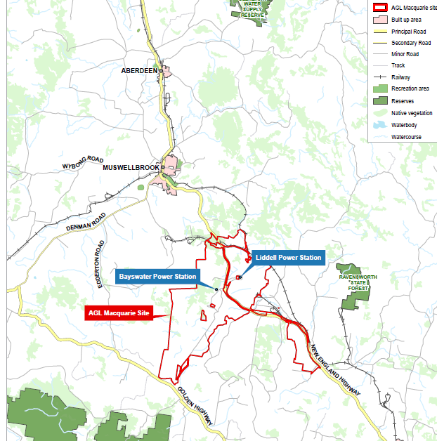

**Map 2 – Aerial**

**Map 3 – Site Identification**

**Site 1** *- Updated post-exhibition minor boundary refinement – May 2025*

Original boundary

Adjusted boundary

## 

**Site 2** *- Updated post-exhibition minor boundary refinement – May 2025*

Original boundary

Adjusted boundary

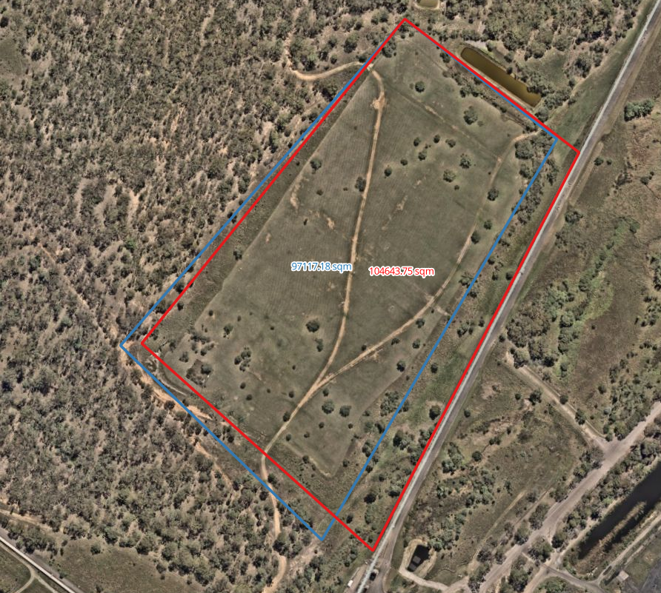

**Site 3** *- Updated post-exhibition minor boundary refinement – May 2025*

Original boundary

Adjusted boundary

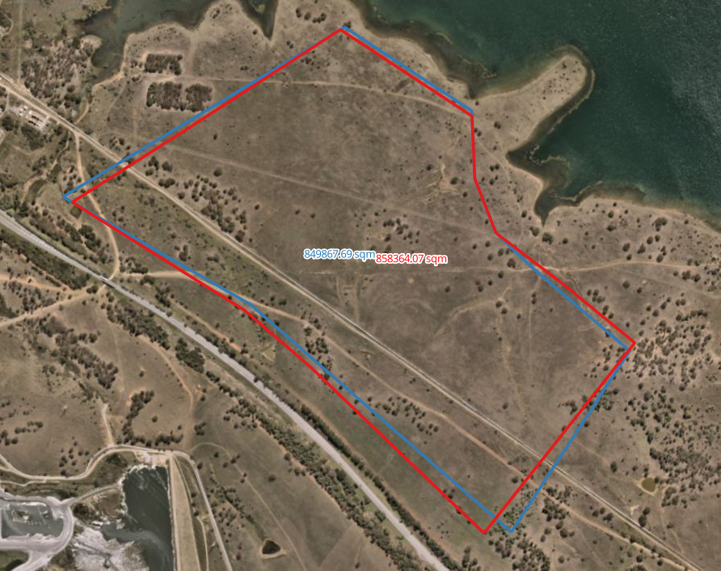

**Map 4 – Bush Fire**

**Map 5 – Zoning and Key Site Maps**

## *Current Land Zoning – SP2 Infrastructure*

b) Proposed Key Sites map

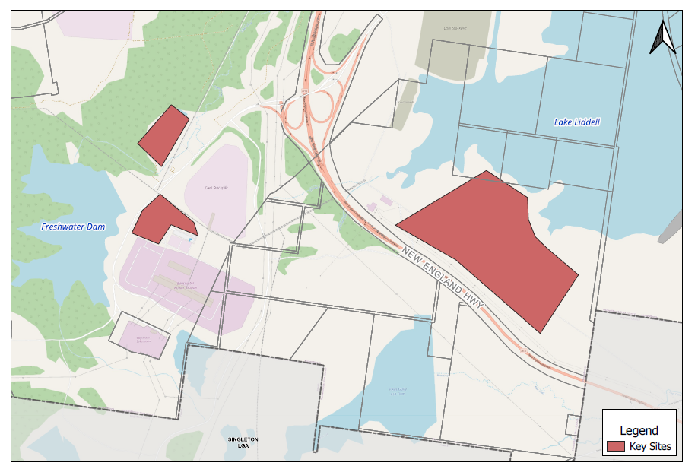

**Part 5 – COMMUNITY CONSULTATION**

The Gateway determination provided as **Attachment 5** requires the planning proposal to be public exhibited for a minimum of 20 working days.

The planning proposal is categorised as a “standard” LEP amendment. The exhibition is required to comply with the notice requirements and the specifications for material that

must be made publicly available along with planning proposals as identified in

the *Local Environmental Plan Making Guidelines* (Department of Planning and Environment, 2021).

No submissions were received during the exhibition period.

**Part 6 – PROJECT TIMELINE**

|  |  |
| --- | --- |
| **Action** | **Timeframe** |
| Gateway Determination issued | 13/06/2024 |
| Technical Studies (Preliminary Site Investigation) received | 19/12/2024 |
| Public exhibition (commencement and completion dates) | 04/02/2025 – 10/03/2025 (20 days) |
| Timeframe for government agency consultation | 09/12/2024 – 17/01/2025 |
| Date of Public hearing (if required) |  |
| Consideration of agency and community submissions | March 2025 |
| Approval of any Ministers S9.1 Direction inconsistencies | March 2025 |
| Report to Council to finalise planning proposal | April 2025 |
| Date RPA will make Plan (if delegated) | May 2025 |
| Date RPA will forward to the Department for notification (if not delegated) |  |

Council intends to exercise its functions of the local plan-making authority under section 3.36(2) of the EP&A Act provided it satisfies the following requirements:

1. the planning proposal authority has satisfied all the conditions of the gateway determination;
2. the planning proposal is consistent with applicable directions of the Minister under section 9.1 of the EP&A Act or the Secretary has agreed that any inconsistencies are justified; and
3. there are no outstanding written objections from public authorities.

**Attachment 1**

**Evaluation Criteria for the Issuing of an Authorisation**

**New England Highway, Muswellbrook**

|  |  |  |  |  |
| --- | --- | --- | --- | --- |
| **Evaluation criteria for the issuing of an Authorisation** | | | | |
| **(Note – where the matter is identified as relevant and the requirement has not been met, council is to attach information to explain why the matter has not been addressed)** | **Council**  **response** | | **Department assessment** | |
| **Y/N** | **Not Relevant** | **Agree** | **Disagree** |
| Is the planning proposal consistent with the Standard Instrument Order, 2006? | Y |  |  |  |
| Does the planning proposal contain an adequate explanation of the intent, objectives, and intended outcome of the proposed amendment? | Y |  |  |  |
| Are appropriate maps included to identify the location of the site and the intent of the amendment? | Y |  |  |  |
| Does the planning proposal contain detail related to proposed consultation? | Y |  |  |  |
| Is the planning proposal compatible with an endorsed regional or sub-regional planning strategy or a local strategy endorsed by the Secretary? | Y |  |  |  |
| Does the planning proposal adequately address any consistency with all relevant S9.1 Planning Directions? | Y |  |  |  |
| Is the planning proposal consistent with all relevant State Environmental Planning Policies (SEPPs)? | Y |  |  |  |
| **Minor Mapping Error Amendments** | | | | |
| Does the planning proposal seek to address a minor mapping error and contain all appropriate maps that clearly identify the error and the manner in which the error will be addressed? |  | √ |  |  |
| **Heritage LEPs** | | | | |
| Does the planning proposal seek to add or remove a local heritage item and is it supported by a strategy/study endorsed by the Heritage Office? | N |  |  |  |
| Does the planning proposal include another form of endorsement or support from the Heritage Office if there is no supporting strategy/study? | N |  |  |  |
| Does the planning proposal potentially impact on an item of State Heritage Significance and if so, have the views of the Heritage Office been obtained? | N |  |  |  |
| **Reclassifications** | | | | |
| Is there an associated spot rezoning with the reclassification? |  | √ |  |  |
| If yes to the above, is the rezoning consistent with an endorsed Plan of management (POM) or strategy? |  | √ |  |  |
| Is the planning proposal proposed to rectify an anomaly in a classification? |  | √ |  |  |
| Will the planning proposal be consistent with an adopted POM or other strategy related to the site? |  | √ |  |  |
| Has Council confirmed whether there are any trusts, estates, interests, dedications, conditions, restrictions or covenants on the public land and included a copy of the title with the planning proposal? |  | √ |  |  |
| Has council confirmed that there will be no change or extinguishment of interests and that the proposal does not require the Governor’s approval? |  | √ |  |  |
| Has the council identified that it will exhibit the planning proposal in accordance with the Department’s Practice Note regarding *classification and reclassification of public land through a local environmental plan and Best Practice Guideline for LEPs and Council Land*? |  | √ |  |  |
| Has council acknowledged in its planning proposal that a Public Hearing will be required and agreed to hold one as part of its documentation? |  | √ |  |  |
| **Spot Rezonings** | | | | |
| Will the planning proposal result in a loss of development potential for the site (i.e. reduced FSR or building height) that is not supported by an endorsed strategy? | N |  |  |  |
| Is the rezoning intended to address an anomaly that has been identified following the conversion of a principal LEP into a Standard Instrument LEP format? | N |  |  |  |
| Will the planning proposal deal with a previously deferred matter in an existing LEP and if so, does it provide enough information to explain how the issue that lead to the deferral has been addressed? | N |  |  |  |
| If yes, does the planning proposal contain sufficient documented justification to enable the matter to proceed? |  | √ |  |  |
| Does the planning proposal create an exception to a mapped development standard? | N |  |  |  |
| **Section 3.22 matters** | | | | |
| Does the proposed instrument   1. Correct an obvious error in the principal instrument consisting of a misdescription, the inconsistent numbering of provision, a wrong cross-reference, a spelling error, a grammatical mistake, the insertion of obviously missing words, the removal of obviously unnecessary words or a formatting error? 2. Address matter in the principal instrument that are of a consequential, transitional, machinery or other minor nature? or 3. Deal with matters that do not warrant compliance with the conditions precedent for the making of the instrument because they will not have any significant adverse impact on the environment or adjoining land?   (Note – the Minister/GSC (or Delegate) will need to form an Opinion under section 3.22 of the Act in order for a matter in this category to proceed). |  | √ |  |  |

**Attachment 2**